**Serial Communications II**

**I2C Basics**

Inter-integrated circuit = (I2C, I2C or IIC) communications

* Simple, robust, inexpensive easy-to-use communications
* Standard: 100 kbps, full-speed: 400 kbps, fast: 1Mbps, high-speed: 3.33 Mbps
* 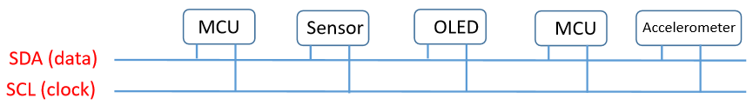Two-wire bus structure with up to 127 devices connected in parallel

If **MCU** talks with the **OLED**, disable all other channels

**Robust communications**

* Verify the correct reception of EVERY byte via ACK=Acknowledged
* Built-in arbitration to eliminate bus conflicts

**Easy-to-use communications**

* I2C Protocols consist of 8-bit words (**word** =  smallest unit that can be addressed on memory)
* Master-slave handshaking

**Serial Packet Structure: Write**

* 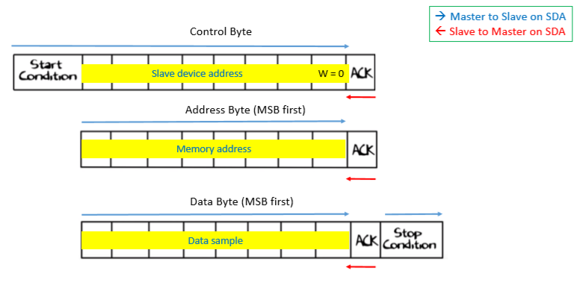Master generates clock signal and initiates communication
* Address byte for selecting the device for data transmission
* R/W bit for declaring reading or writing operation

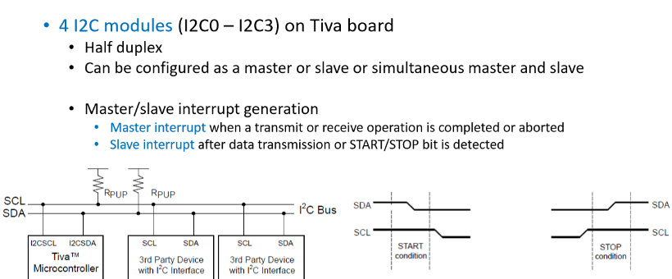**I2C on Tiva C-Series Launchpad**

**Serial Packet Structure: Read**

